|  |
| --- |
| **Lab 5: Integer, Float, Character and String Constant.** |

Exercise 2

Update task 1 of Lab#3 and split input stream on white spaces, punctuators (**(**, **)**, **[**, **]**, **{**, **}**, **.**, **,**) and operators (+, -, *, /, %,&,&&,!,|,||) of C++ language. Ignore white spaces, for punctuators and operators write a method to classify them.

**Source Code:**

#include<iostream>

#include<fstream>

#include<stdio.h>

#include<string>

using namespace std;

int main(){

ifstream input;

input.open("sample.txt");

if(!input){

cout<<"unable to open file"<<endl;

exit(1);

}

string x;

string sum;

while(input >> x){

sum+=x;

}

input.close();

cout<<"sum="<<sum<<endl;

string str=sum;

cout << "\n\nYou Entered:\n\n";

string temp,temp2, temp3;

for(int i=0;i<str.length();i++)

{

if(str[i]!=';' && str[i]!='(' && str[i]!=')' && str[i]!='[' && str[i]!=']' && str[i]!='{' && str[i]!='}' && str[i]!='.' && str[i]!=',' &&

str[i]!='"' && str[i]!='+' && str[i]!='-' && str[i]!='*' && str[i]!='/' && str[i]!='%' && str[i]!='&' &&

str[i]!='!' && str[i]!='|' && str[i]!='=' && str[i]!='<' && str[i]!='>')

{

temp+=str[i];

}

else

{

cout<<temp<<"\n";

temp2+=str[i];

temp3+=str[i];

temp3+=str[i+1];

if(temp3=="||" || temp3=="&&" || temp3=="!=" || temp3=="==" || temp3=="<=" || temp3==">=")

{

cout<<temp3<<"\ntemp3";

i++;

}

else{

cout<<temp2<<"\n";

}

temp="";

temp2="";

temp3="";

}

}

}

**SCREENSHOT:**

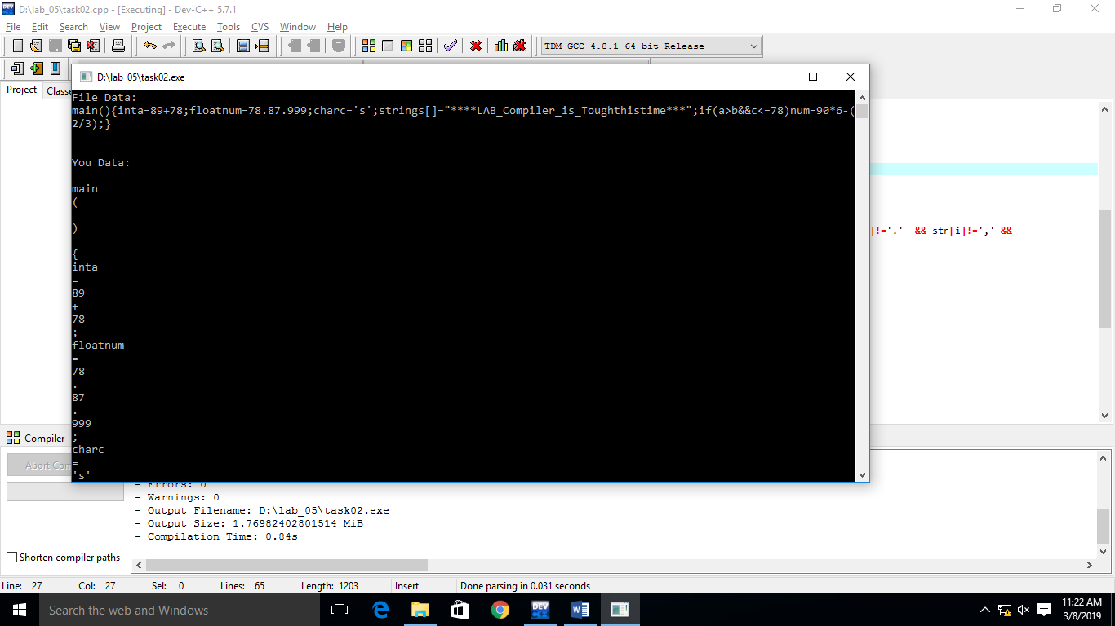

Exercise 3

Write a method to recognize valid integer, char, float and string constants.

**SOURCE CODE:**

**INTEGER:**

#include<iostream>

#include<string>

using namespace std;

int TF(char a, int cstate){

int state = cstate;

int TT[4][3] = {{1,2,3},

{3,2,3 },

{3,2,3 },

{3,3,3} };

if(a == '+' || a == '-'){

state = TT[state][0];

}

else if(a >= '0' && a <= '9'){

state = TT[state][1];

}

else{

state = 3;

}

return state;

}

int main(){

int cstate =0;

int fstate = 2;

string input;

cout << "Enter any integer: ";

getline(cin,input);

for(int i = 0 ; i< input.length(); i++){

cstate = TF(input[i], cstate);

if(cstate == 3) break;

}

if(cstate == fstate){

cout << "valid integer";

}

else{

cout << "Invalid integer";

}

}

**SCREENSHOT:**

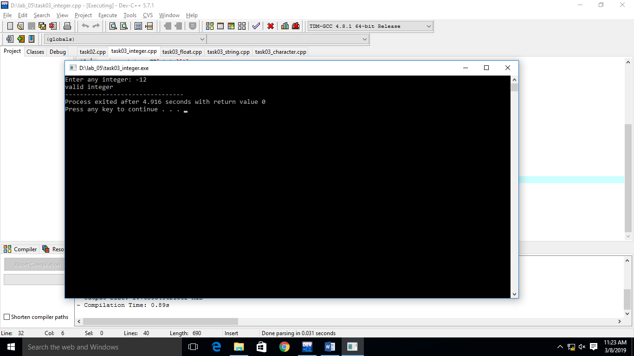

**Character:**

#include <iostream>

#include<string>

using namespace std;

int Transition_func(int state, char ch)

{

int TT[6][4] = { {1,5,5,5}, {5,2,5,4}, {3,5,5,5}, {5,5,5,5}, {2,5,2,2}, {5,5,5,5} };

if (ch == '\'' && (state == 0 || state == 2))

{

return TT[state][0];

}

else if ((state!=4) &&( isalpha(ch) || isdigit(ch)))

{

return TT[state][1];

}

else if (ch=='\'' || ch=='\"' )

{

return TT[state][2];

}

else if( (state == 4 && (ch=='n' || ch=='t')))

{

return TT[state][2];

}

else if(ch == '\\'){

return TT[state][3];

}

else

{

return 0;

}

}

int main()

{

string input;

int I_state = 0;

int F_state = 3;

int C_state = I_state;

cout << "Enter any character for validation: \n";

cin >> input;

for(unsigned int i=0; i< input.length(); i++)

{

C_state = Transition_func(C_state, input[i]);

if(C_state==5){

break;

}

}

if (C_state == F_state)

{

cout << "Valid Character "<<endl;

}

else

{

cout << "InValid Character "<<endl;

}

}

**SCREENSHOT:**

